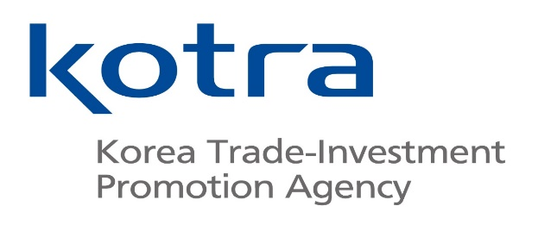
세계와 미래를 연결하는 대한민국 글로벌 비즈니스 플랫폼
이경미 (차장)
Fondée en 1962, KOTRA est une agence nationale sous la tutelle du Ministère du commerce, de l’industrie et de l’énergie qui contribue au développement de l’économie nationale en se focalisant sur la promotion du commerce, l’investissement entre des sociétés nationales et étrangères, le soutien à la coopération technologique industrielle, etc.
KOTRA est implantée à l’international dans 129 centres répartis dans 84 pays.
LEE Kyungmi est directrice adjointe à KOTRA Paris. Lors de cette présentation, elle reviendra sur son parcours professionnel.
KOTRA는 1962년 설립된 국내 중소.중견기업의 수출 지원 및 외국인 투자유치를 지원하는 산업부 산하 무역투자진흥기관입니다.
국내뿐만 아니라 전세계 84개국 129개 무역관에서 무역 투자를 지원하고 있습니다.
이번 특강은 파리무역관의 이경미 차장님을 모시게 되었습니다.
Established in 1962, KOTRA is Korea’s national agency under the Ministry of Trade, Industry and Energy that contributes to the development of the national economy by performing work such as trade promotion, investment between domestic and foreign companies, support of industrial technology cooperation, etc.
KOTRA is present internationally in 129 trade centers in 84 countries.
Lee Kyungmi is deputy director at KOTRA Paris. In this presentation, she will talk about her journey.

